HOW TO DONATE ONLINE

Support Rosser Elementary by donating online — quick, secure, and includes an instant tax receipt.

https://burnaby.schoolcashonline.com/Fee/Details/635/16/false/true?school=577&initiative=1

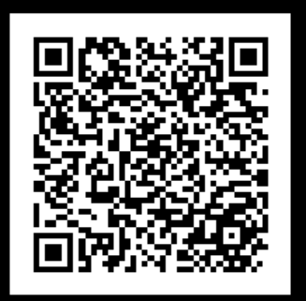
- Open the donation link or scan the QR code
The link/QR code will take you directly to the Burnaby School District donation webpage.

- Choose a donation amount (see next page)
Select one of the preset amounts or enter your own amount.

- Confirm the school
The default school is Rosser Elementary School. Please ensure Rosser Elementary remains selected.

- Confirm the initiative
The initiative is set to GENERAL. No changes are required unless instructed otherwise.

- Add a Message - important for specific programs
If you would like your donation to support a specific program, activity, or purpose, please clearly indicate this in the Message field.
If no message is entered, the donation will be treated as a general donation.

- Complete checkout
Finish the checkout process as prompted.

- Receive your tax receipt
An instant donation receipt will be emailed to you upon successful payment.

